# Efficient Delta Hedging with Transaction Costs

This project involved the development of a delta hedge for a 1y ATM call option using realised volatility given a set of parameters and scenario variations.

For all workbooks, see <https://github.com/afoster28/delta_hedge>.

1. The expected value and standard deviation of P&L assuming portfolio rebalancing to net zero-delta occurs at every step:

Mean = 1.18

Std dev = 0.26

Option price is calculated using implied vol, whereas the hedging portfolio constituent variables assume realised vol. Position value then incorporates both of these elements. The P&L path has a random component that diminishes towards maturity.

Hedge P&L takes into account the final position value and starting option price; it aligns with the difference in option prices under realised and implied vols.

1000 steps were used and 10,000 paths were simulated.

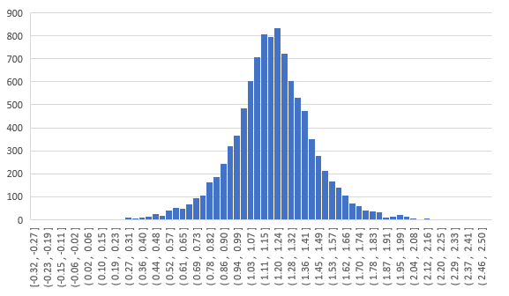

1. Each trade in the underlying stock now costs 0.1%. This cost is applied to the absolute value of the period-on-period change in share value of the hedging portfolio, which takes into account the underlying change in share position and the new asset price.

The exception to this is the first period in which the starting stock position is initiated, thereby inducing a relatively higher cost on the entirety of this position.

Absolute value is used throughout, as the cost is incurred regardless of trade direction.

Hedge P&L still incorporates the final position value and the starting option price, as well as a subtraction of the total cost incurred across all rehedging periods.

1. Reducing the number of rehedges from 1000 to 100 produces:

Mean = 0.71

Std dev = 0.79

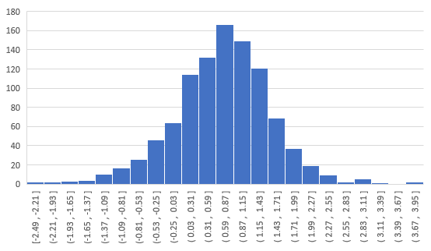

1. Reducing the number of rehedges from 1000 to 10 produces:

Mean = 1.02

Std dev = 2.41

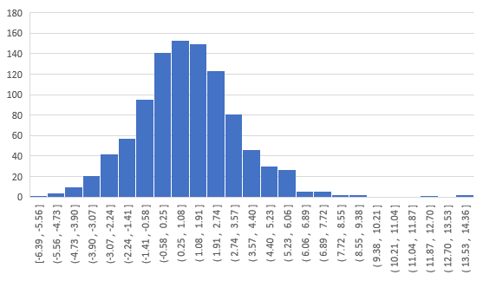

1. Adopting a trigger-based rehedging strategy whereby the portfolio is rebalanced only if delta changes by 5 percentage points produces:

Mean = 0.49

Std dev = 0.55

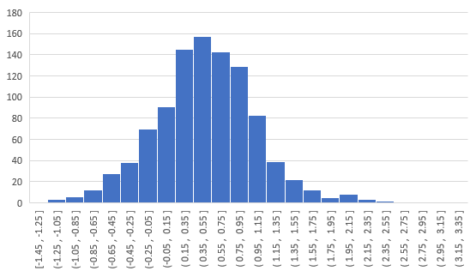

The entire time horizon spans 1000 steps. The hedge is executed at the start and triggered in periods where the current delta exceeds $1.05×{Delta}_{Previous hedge}$ or is less than $0.95×{Delta}_{Previous hedge}$. Number of shares in the hedge portfolio is set to the latest trigger delta; share value still changes with every time step even when the hedge is not triggered due to fluctuating asset price; incremental shares and position value calculations remain unchanged. Trading costs are now incurred only on hedging dates.

The mean number of rehedges in this approach amounts to 280.

It is clear that among approaches 2a, 2b and 2c, approaches 2a and 2c deliver superior outcomes, as indicated by their Sharpe ratios that present the highest returns per unit of volatility with 2a technically being the preferred choice.

Increasing the number of rehedges decreases the uncertainty around P&L, as expected. There is less dispersion in P&L whenever more frequent and targeted hedge adjustments can be performed as asset prices and hence delta change. The approach with the largest number of rehedges, approach 2c, displays the lowest standard deviation of 0.55. However, the increased trade count incurs a higher trading cost overall and decreases the mean to the lowest of 0.49.

Trigger-based rehedging strategies should provide a reasonable balance between the frequency of rehedging (variability of P&L) and the cost incurred for all trades. The more meaningful delta changes are prioritised.

|  |  |  |  |  |
| --- | --- | --- | --- | --- |
|  | **Approach 1** | **Approach 2a** | **Approach 2b** | **Approach 2c** |
| Mean | 1.18 | 0.71 | 1.02 | 0.49 |
| Std dev | 0.26 | 0.79 | 2.41 | 0.55 |
| Sharpe ratio | 4.61 | 0.90 | 0.42 | 0.88 |